1.INSTRUCTOR TABLE DETAILS
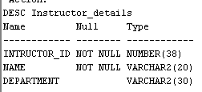
2.COURSE DETAILS
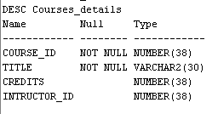
3. STUDENT DETAILS
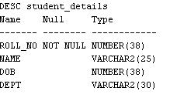
4.ENROLLMENT TABLE
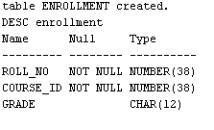
5.ALTERED TABLE
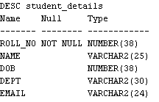

6.INDEX
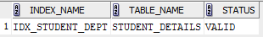
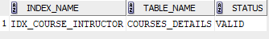
7.DROP

